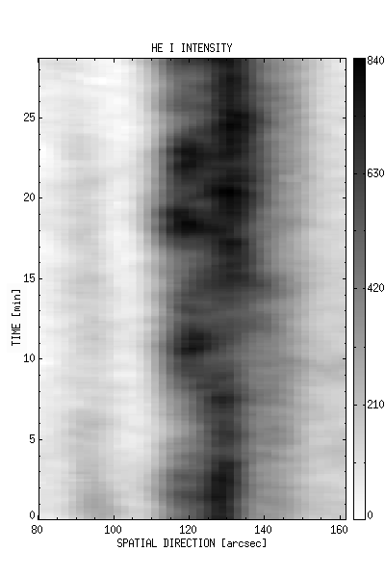 | 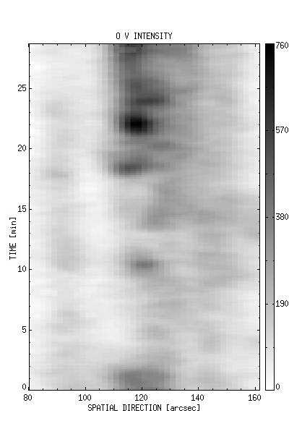
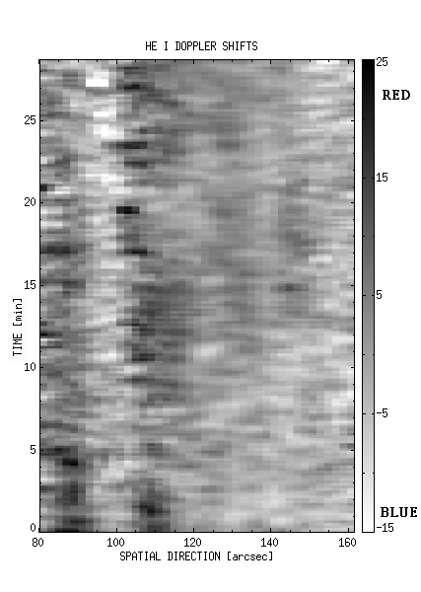 | 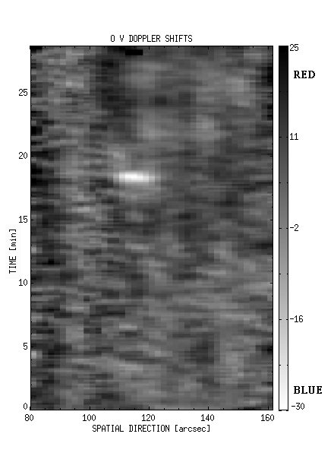
Figure 1: 2D maps of He I and O V intensity and Doppler shifts. Typical network is shown in area between 126” and 142”. Nontypical network is in the area between 114” and 124”. The intensity values are given in erg/cm²/s/ster/Å and the Doppler shifts in km/s. The horizontal axis describes spatial direction and the vertical axis describes time. The solar rotation was not compensated, so the vertical axis presents also the spatial extent of the observed solar features. Positive shifts – red: toward the solar surface; negative shifts – blue: toward the observer.

