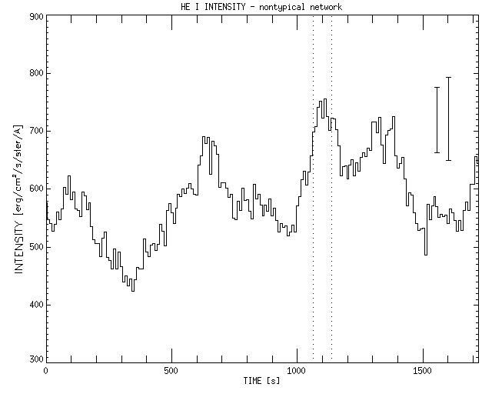
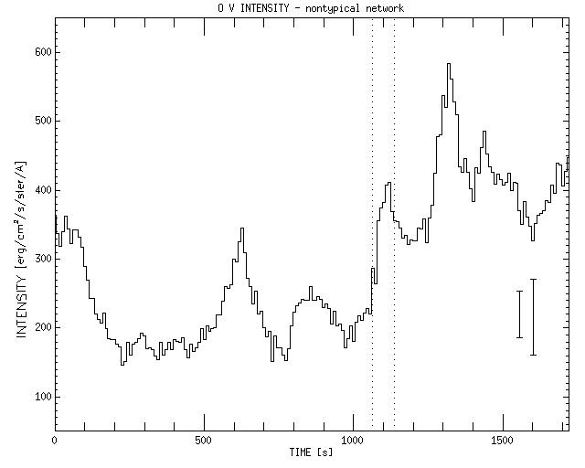
Figure 2: Temporal variation of He I and O V intensities in the nontypical network. The histograms show temporal variatons of He I and O V averaged intensities. Square root error from the displayed mean values (12”) are ±56,3 and ±33,7 erg/cm²/s/ster/Å for He I and O V lines respectively (left error bar). Average value of deviations from the displayed mean values (12”) are ±71,5 and ±55 erg/cm²/s/ster/Å for He I and O V lines respectively (right error bar). The dotted lines show the time interval, in which the TR eruptive event was observed.

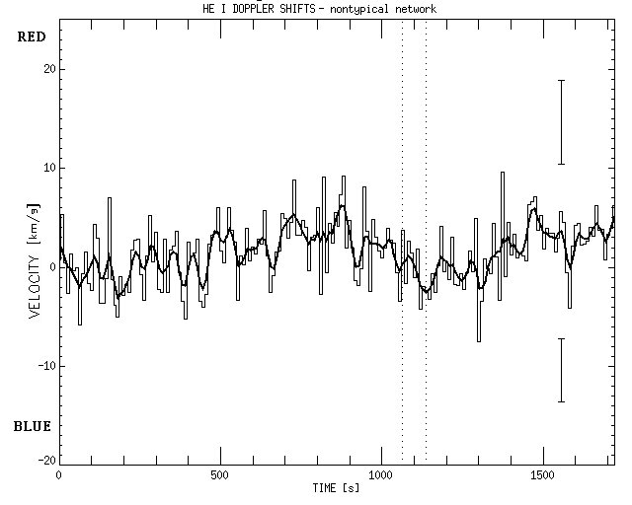
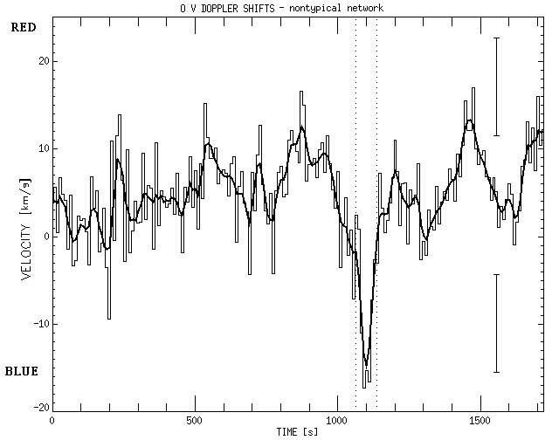
Figure 3: Temporal variation of He I and O V Doppler shifts in the nontypical network. The histograms (thin lines) show original temporal variatons of He I and O V averaged Doppler shifts. The thick lines show smoothed (using the running mean of 5 data points) temporal variations. Square root error from the displayed mean values (12”) are ±4.2 km/s and ±5.6 km/s for He I and
O V lines respectively (top error bar). Average value of deviations from the displayed mean values (12”) are ±3.2 km/s and ±5.5 km/s for He I and O V lines respectively (bottom error bar). The dotted lines show the time interval in which the TR eruptive event was observed. Red – toward the solar surface; blue – toward the observer.

O V spectral profile: 118”, 1092 s.
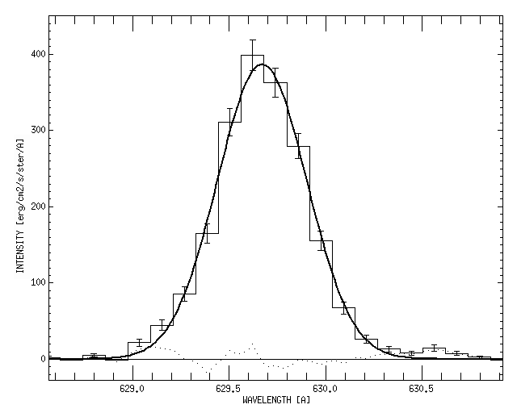
Figure 4: The typical single Gaussian spectral profile of O V line in the eruptive event (118”, 1092 s). The histogram shows the acquired spectral data. The full line gives the single Gaussian fit parameters: I = 386,45 erg/cm²/s/ster/Å; ν_{D} = 629,68 km/s; ξ = 0.33 Å; χ² = 3.95 erg²/cm⁴/s²/ster²/Å². The dotted line shows difference between the spectral data and their fit. The error bars are calculated from Poisson statistics.

O V spectral profiles (114”, 1092 s) – single and two component Gaussian fit
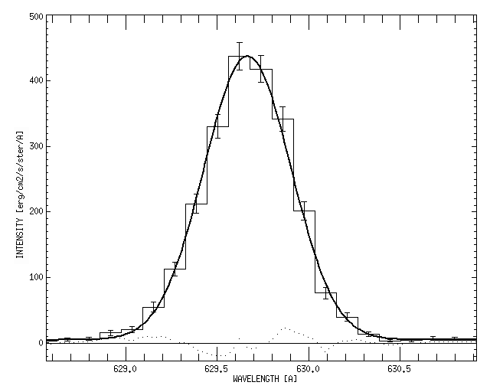 | 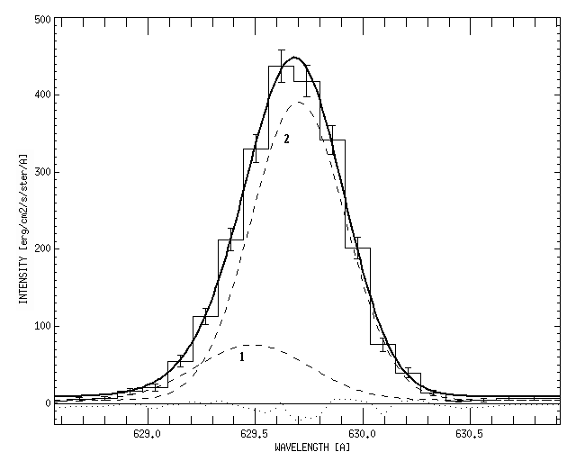
Figure 5: The spectral profile (114”, 1092 s) shows that twocomponent fit might be better. Parameter χ² for one component fit is 1.16 is erg²/cm⁴/s²/ster²/Å² and parameter χ² for two component fit is 0.84 erg²/cm⁴/s²/ster²/Å². The histogram shows the acquired spectral data. The full line is the resulting fit. The dashed lines are two Gaussian components. The dotted line shows difference between data and the resulting fit. The error bars are calculated from Poisson statistics.

Averaged O V spectral profiles (114” – 119” and 1083 s - 1101 s)
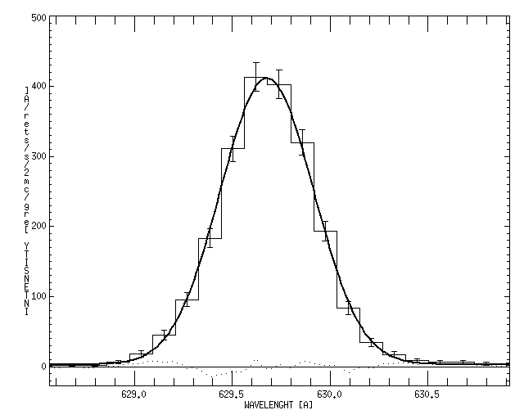 | 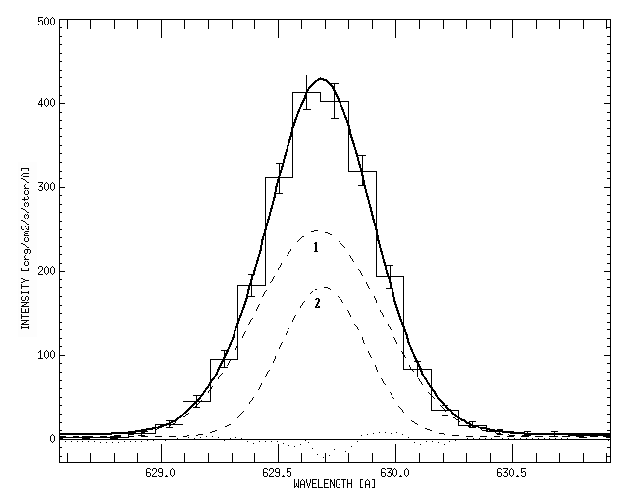
Figure 6: Averaged spectral profile from area 114” – 119” and 1083 s – 1101 s. Parameter χ² for one component fit is 0.88 erg²/cm⁴/s²/ster²/Å² and parameter χ² for two component fit is 0.74 erg²/cm⁴/s²/ster²/Å² . The histogram shows acquired spectral data. The full line is the resulting fit. The dashed lines are two Gaussian components. The dotted line shows difference between data and the resulting fit. The error bars are calculated from Poisson statistics.

